Italy, Campania: The White-Wine Zeitgeist
By Monica Larner
Over the years, I’ve watched Campania’s wine story come full circle. I experienced the early trattoria-driven popularity of its easy-drinking whites, their eclipse in the shadow of premium reds and now a thrilling resurgence of the region’s terroir-driven whites. White to red to white: it’s not just a comeback; it’s a reinvention.

White grape protagonists Greco, Fiano and Falanghina (plus many more obscure native varieties such as Coda di Volpe, Pallagrello Bianco and Biancolella) are enjoying an energetic revival thanks to passionate winemakers. Vintners are using these grapes today to achieve freshness, minerality and typicity. More attention is being paid to site selection, altitude and soils. Indigenous grapes are more carefully matched to the unique geology of the region, which has volcanic tufa, ash and limestone.
The result is contemporary, small-batch releases that rely on an interplay of old vines, volcanic soils, a marine climate and a hands-off winemaking approach that captures the Campania white wine zeitgeist.

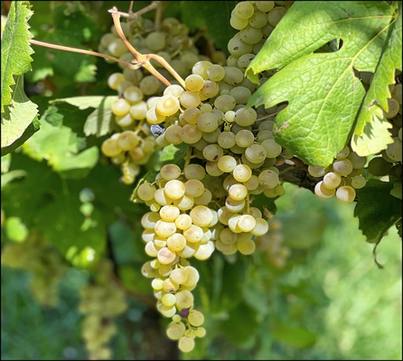

The November 23, 1980, Irpinia earthquake (with a magnitude of 6.9 on the Richter scale) was one of the deadliest and most destructive seismic events in modern Italian history. It had a profound impact on the social structure and economy of Southern Italy, and it reset many aspects of the local wine industry. Winemakers who lost their homes and cellars were forced to rebuild, upgrading to better facilities and equipment. Others took this opportunity to replant and replace less efficient vineyards to indigenous grapes that underline local identity, rather than defaulting to higher-volume and market-safe options.

The red grape Aglianico—the base of the prestigious Taurasi appellation—began its rapid ascent. The so-called “Barolo of the South” was recognized for its complexity, structure and capacity for long cellar aging. Taurasi was one of the first red wines in the Italian south to command high retail prices and critical success in the 1990s and 2000s thanks to a handful of visionary vintners.

However, it is clear to me that Aglianico’s long ripening cycle has become a liability in the current era of climate change. The red grape thrives in high acidity, late-harvest conditions lasting well into November. Starting with record-breaking heat in 2003 and spanning the past two decades to the scorching hot 2020, 2021, 2022 and 2023 vintages, Taurasi’s popularity has plateaued or even declined, especially when compared to lighter reds and exciting Campania whites. My own tastings have registered dry or brittle tannins, overripe flavors and shortened drinking windows in many Taurasi wines.

The pendulum has swung back to whites. There are many signs of this trend in this report. For example, Feudi di San Gregorio has upgraded its popular Greco di Tufo Cutizzi and the Fiano di Avellino Pietracalda to Riserva status. And vintner Libero Rillo of Fontanavecchia has released a new series of cru-specific expressions of Falanghina. That same grape is the focus of very exciting work in the Campi Flegrei by estates such as Cantine Astroni and La Sibilla.

There is no doubt in my mind that white wines made by Quintodecimo, Casa d’Ambra, Marisa Cuomo and Ciro Picariello, to name a few, are benchmarks for vino bianco Italiano.

2020 Fontanavecchia Falanghina del Sannio Taburno Libero B Particella 148 – 91 P

2020 Fontanavecchia Falanghina del Sannio Taburno Libero T Particella 031 – 90 P

2023 Terre Stregate Falanghina del Sannio Svelato – 88 P

Donnachiara – diverse
San Salvatore - diverse

